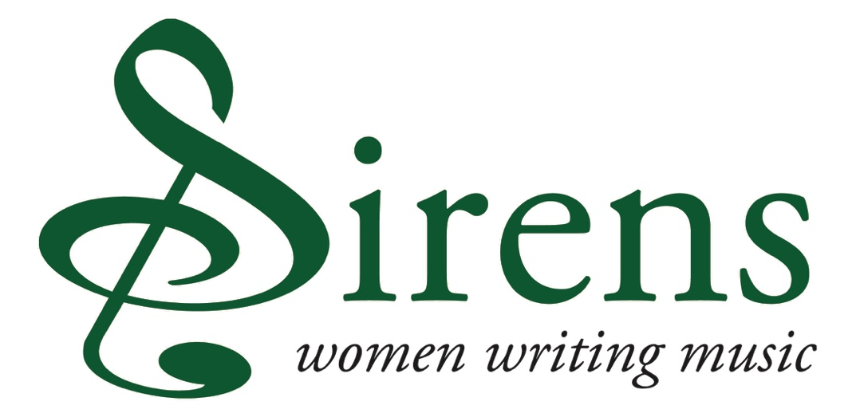

**PROJECT APPLICATION**

**DEADLINE FOR SUBMISSION OF THIS APPLICATION: FRIDAY 28 FEBRUARY 2025, 12 NOON**

1. **CONTACT DETAILS AND ELIGIBILITY**

**1.1** Please provide your **contact** details for this application. N.B. **All correspondence** will be sent to this contact

Name:

Name of orchestra that you are representing:

Email:

Telephone (work):

Postal address:

**1.2** Is your orchestra a **full or associate member of the ABO?**

*Please note that only orchestras who are ABO full and associate members can apply for a Sirens grant.* ***If your orchestra has been in receipt of a grant for two years in a row, you may not apply for another this year****. Please allow a gap of one year before applying to us again*

**1.3 Request amount** (up to £4000)

*Please ensure that this amount corresponds with the figure allocated in your budget.*

1. **YOUR CHOSEN PIECE** 
   1. Please state the piece and composer that your orchestra is interested in programming and promoting

*There is a list of works by historical women, which might be helpful to use as a guide, on the website* [www.womenofnote.co.uk/repertoire.htm](http://www.womenofnote.co.uk/repertoire.htm) *and it is downloadable here:* [www.womenofnote.co.uk/ABO_Sirens.pdf](http://www.womenofnote.co.uk/ABO_Sirens.pdf).

**2.2** Please provide a **link to a recording** if available

**2.3** Please provide a **brief background to the piece, your project and organisation** *(in no more than 100 words)*

**2.4 Please make the case for the piece of music you are interested in programming and promoting** *(in no more than 100 words)*

**2.5** Please provide details of **how you will programme the proposed Sirens piece in your orchestral season and how you will ensure that it features prominently within the season?**

*Kindly include dates and times, information on venues (including venue name, town, capacity, anticipated audience numbers) and any additional performers.*

*It is preferable for the piece to be performed more than once and will strengthen the proposal, but it is not essential and will not make the application ineligible.*

This activity must **take place** between **2025 and 2027.**

We also request the whole concert programme including the Sirens piece and why this programme will be strong artistically and will inspire your audiences. The higher the percentage of female composers represented in the programme, the more performances and the more reach that the work will have, the more likely the grant is to be awarded.

*Pieces by living women composers may be included in the programme, as long as the historical piece is the main work in the plan and the one for which you are seeking funding. As the Sirens Fund has become increasingly competitive, please be concise.(in no more than 200 words)*

1. **ENGAGEMENT AND PROMOTION**

**3.1** What **learning and participation work, if any,** will be associated with the piece? *(in more no more than 150 words)*

**3.2** Please summarise your **marketing and PR strategy** to **promote the Sirens piece** *(in more no more than 150 words)*

**3.3.** We would appreciate an overview report of the project, including audience numbers, in order for you to receive the final 20% of your grant. **How do you plan to assess the impact of your work?** *(in more no more than 100 words)*

1. **Your budget**

The information gathered in the expenditure and income tables below will be used to ensure that all applications are assessed on an equal footing.

It’s essential that Sirens funding contributes to the direct costs of the proposed piece of music only, and therefore it’s important that you tell us what you would like our funding to support. Please tick the right hand column ‘Sirens support’ to indicate which budget area you would like us to support. The tables provide the option to provide other expenditure/income headings, if required.

The tables also offer the opportunity to add short descriptions to expenditure and income headings. This is to provide additional information for assessors and the ABO team, but it is not mandatory.

|  |  |  |  |
| --- | --- | --- | --- |
| **EXPENDITURE** | **DESCRIPTION** | **AMOUNT** | **SIRENS SUPPORT?**  **Y/N** |
| **Musician fees** e.g. rehearsal and performance fees for the ensemble |  |  |  |
| **Music hire fees** |  |  |  |
| **Rehearsal venue hire** |  |  |  |
| **Instrument hire** |  |  |  |
| **Touring costs in the UK** e.g. travel, petrol |  |  |  |
| **Learning & Participation** e.g. fees for music leaders, evaluation etc |  |  |  |
| **Marketing & Promotion** e.g. hire of PR professionals, advertising |  |  |  |
|  | **TOTAL** |  |  |
| **In-kind expenditure** e.g. venue hire offered at no extra cost |  |  |  |

|  |  |  |  |
| --- | --- | --- | --- |
| **INCOME** | **DESCRIPTION** | **CONFIRMED AMOUNT** | **UNCONFIRMED AMOUNT** |
| **Ticket sales/performance fees** |  |  |  |
| **Programme/merchandise Sales** |  |  |  |
| **Own cash contribution** |  |  |  |
| **Arts Council** can include Arts Council England, Creative Scotland, Arts Council Northern Ireland and Arts Council Wales |  |  |  |
| **Trusts & Foundations** e.g. Paul Hamlyn Foundation, Hope Scott Trust, The Millennium Stadium Charitable Trust |  |  |  |
| **Corporate donations** e.g. money raised from companies including publishers, record companies |  |  |  |
| **ABO Sirens** This figure must match the request amount noted in your application |  |  |  |
| **Other income** |  |  |  |
|  | **Totals** |  |  |
|  | **Overall total (confirmed and unconfirmed)** |  |  |
| **In-kind income** must match in kind expenditure figure |  |  |  |
| **In kind expenditure – in kind income = (The difference should be £0)** |  |  |  |

**DEADLINE FOR SUBMISSION OF THIS APPLICATION: FRIDAY 28 FEBRUARY 2025, 12 NOON**

**Please email your application to Fiona@abo.org.uk**