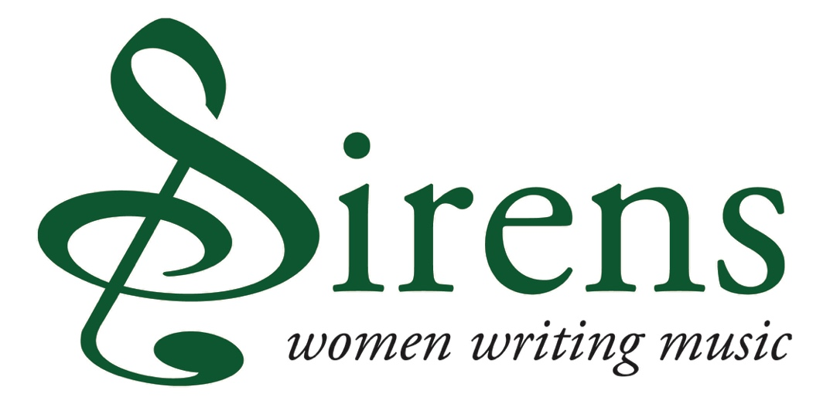

PROJECT APPLICATION

DEADLINE FOR SUBMISSION OF THIS APPLICATION: FRIDAY 27 FEBRUARY 2026, 12 NOON

- CONTACT DETAILS AND ELIGIBILITY

1.1 Please provide your contact details for this application. N.B. All correspondence will be sent to this contact

Name:

Name of orchestra that you are representing:

Email:

Telephone (work):

Postal address:

1.2 Is your orchestra a full or associate member of the ABO?

Please note that only orchestras who are ABO full and associate members can apply for a Sirens grant. If your orchestra has been in receipt of a grant for two years in a row, you may not apply for another this year.

1.3 Request amount (up to £4000)

Please ensure that this amount corresponds with the figure allocated in your budget.

- YOUR CHOSEN PIECE

  - Please state the piece and composer that your orchestra is interested in programming and promoting
There is a list of works by historical women, which might be helpful to use as a guide, on the website www.womenofnote.co.uk/repertoire.htm and it is downloadable here: www.womenofnote.co.uk/ABO_Sirens.pdf.

2.2 Please provide a link to a recording if available

2.3 Please provide a brief background to the piece, your project and organisation (in no more than 100 words)

2.4 Please make the case for the piece of music you are interested in programming and promoting (in no more than 100 words)

2.5 Please provide details of how you will programme the proposed Sirens piece in your orchestral season and how you will ensure that it features prominently within the season?

Kindly include dates and times, information on venues (including venue name, town, capacity, anticipated audience numbers) and any additional performers.

It is preferable for the piece to be performed more than once and will strengthen the proposal, but it is not essential and will not make the application ineligible.

This activity must take place between 2026 and 2028.

We also request the whole concert programme including the Sirens piece and why this programme will be strong artistically and will inspire your audiences. The higher the percentage of female composers represented in the programme, the more performances and the more reach that the work will have, the more likely the grant is to be awarded.

Pieces by living women composers may be included in the programme, as long as the historical piece is the main work in the plan and the one for which you are seeking funding. As the Sirens Fund has become increasingly competitive, please be concise.(in no more than 200 words)

- ENGAGEMENT AND PROMOTION

3.1 What learning and participation work, if any, will be associated with the piece? (in more no more than 150 words)

3.2 Please summarise your marketing and PR strategy to promote the Sirens piece (in more no more than 150 words)

3.3. We would appreciate an overview report of the project, including audience numbers, in order for you to receive the final 20% of your grant. How do you plan to assess the impact of your work? (in more no more than 100 words)

- Your budget

The information gathered in the expenditure and income tables below will be used to ensure that all applications are assessed on an equal footing.

It’s essential that Sirens funding contributes to the direct costs of the proposed piece of music only, and therefore it’s important that you tell us what you would like our funding to support. Please tick the right hand column ‘Sirens support’ to indicate which budget area you would like us to support. The tables provide the option to provide other expenditure/income headings, if required.

The tables also offer the opportunity to add short descriptions to expenditure and income headings. This is to provide additional information for assessors and the ABO team, but it is not mandatory.

EXPENDITURE | DESCRIPTION | AMOUNT | SIRENS SUPPORT?  Y/N
Musician fees e.g. rehearsal and performance fees for the ensemble
Music hire fees
Rehearsal venue hire
Instrument hire
Touring costs in the UK e.g. travel, petrol
Learning & Participation e.g. fees for music leaders, evaluation etc
Marketing & Promotion e.g. hire of PR professionals, advertising
 | TOTAL
In-kind expenditure e.g. venue hire offered at no extra cost

INCOME | DESCRIPTION | CONFIRMED AMOUNT | UNCONFIRMED AMOUNT
Ticket sales/performance fees
Programme/merchandise Sales
Own cash contribution
Arts Council can include Arts Council England, Creative Scotland, Arts Council Northern Ireland and Arts Council Wales
Trusts & Foundations e.g. Paul Hamlyn Foundation, Hope Scott Trust, The Millennium Stadium Charitable Trust
Corporate donations e.g. money raised from companies including publishers, record companies
ABO Sirens This figure must match the request amount noted in your application
Other income
 | Totals
 | Overall total (confirmed and unconfirmed)
In-kind income must match in kind expenditure figure
In kind expenditure – in kind income = (The difference should be £0)

DEADLINE FOR SUBMISSION OF THIS APPLICATION: FRIDAY 27 FEBRUARY 2026, 12 NOON

Please email your application to Fiona@abo.org.uk

